**Dashboard Design**

| Date | 31 December 2024 |
| --- | --- |
| Team ID | 17 |
| Project Name | VoyageVista: Illuminating Insights from Uber Expeditionary Analytics Using Tableau |
| Maximum Marks | 3 Marks |

Creating an effective dashboard involves thoughtful design to ensure that the presented information is clear, relevant, and easily understandable for the intended audience. Here are some key principles and best practices for dashboard design

**Activity 1: Interactive and visually appealing dashboards**

Creating interactive and visually appealing dashboards involves a combination of thoughtful design, effective use of visual elements, and the incorporation of interactive features. Here are some tips to help you design dashboards that are both visually appealing and engaging for users so take care of below points

* Clear and Intuitive Layout
* Use Appropriate Visualizations
* Colour and Theming
* Interactive Filters and Slicers
* Drill-Down Capabilities
* Responsive Design
* Custom Visuals and Icons
* Use of Infographics

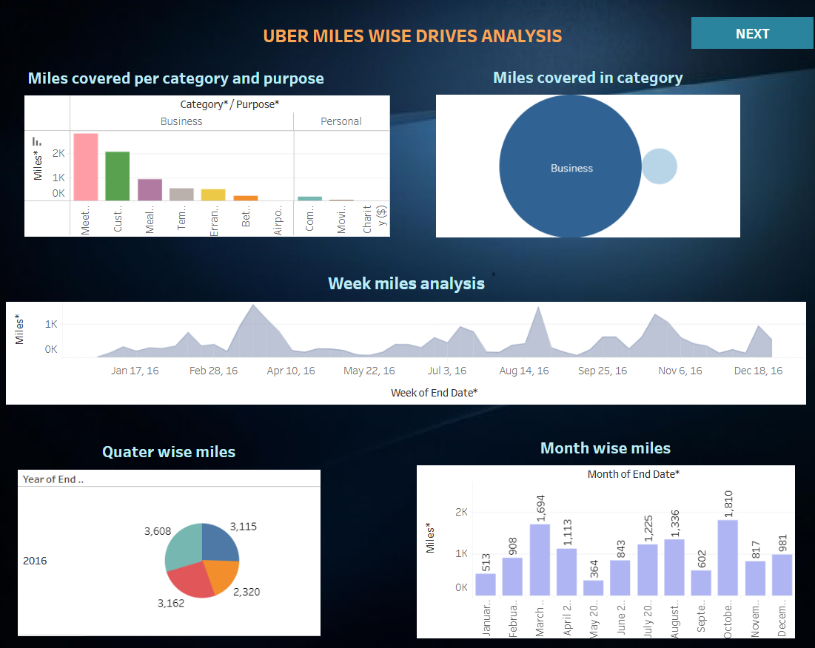

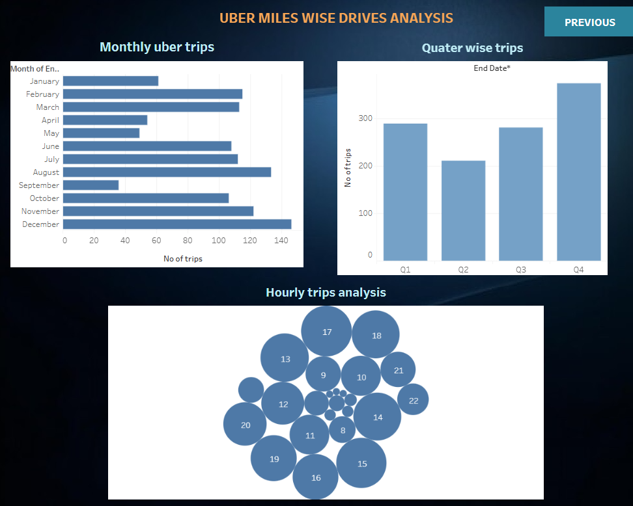

**Here are five potential outcomes from the dashboard image provided:**

The dashboard titled "UBER MILES WISE DRIVES ANALYSIS" presents key insights into Uber ride patterns, miles covered, and trip distributions. Below are the key takeaways:

**1. Miles Covered Analysis**

* Business vs. Personal Usage: The majority of miles covered fall under the *Business* category, indicating that Uber rides are predominantly used for work-related purposes.
* Miles by Category and Purpose: Work-related trips, client meetings, and team outings cover the highest mileage, whereas personal trips have minimal miles covered.
* Trend Over Time: The weekly miles analysis suggests periodic spikes, indicating fluctuating demand possibly due to events, business travel cycles, or seasonal factors.

**2. Trip Analysis by Time Intervals**

* Monthly Trip Distribution: The highest number of trips occurred in *September*, suggesting increased ride activity during this period, possibly due to work resumption after vacations.
* Quarterly Trends: Q4 (October–December) recorded the highest number of trips, indicating a significant year-end increase in travel demand, potentially due to holiday or business-related travel.
* Hourly Trips Distribution: Peak trip hours appear to be spread across various times of the day, but high activity in evening or morning hours could indicate commuting trends.

**3. Seasonal Trends and Operational Insights**

* High Business Travel Demand: Since a significant number of rides fall under the business category, Uber could consider targeted promotions or corporate ride packages.
* Potential Surge Pricing Windows: Identifying peak hours and high-demand months allows Uber to optimize surge pricing strategies.
* Regional Analysis Possibility: While the dashboard doesn’t explicitly showcase geographic distribution, integrating location-based insights could further refine operational decisions.

**Activity 2**

Publish Dashboard on Tableau Public and Paste the Dashboard Public link below:

<https://public.tableau.com/views/Uber_project_dash_board2/TripsWiseDashboard?:language=en-US&:sid=&:redirect=auth&:display_count=n&:origin=viz_share_link>